

DOCAYA
Enterprise Electronic Document Management System
Functional & Business Design Specification
Prepared for the Client, United Arab Emirates
Prepared by Hypermine AI | Intelligence. Amplified.

Document Details
Control, ownership and approval information

Document Control
Document Owner | To be confirmed
Business Owner | To be confirmed
Classification | Internal / Controlled
Approval Status | Pending approval

Revision History
Version | Date | Description | Author
0.1 | To be confirmed | Initial controlled draft | To be confirmed

Review and Approval
Role | Name | Signature | Date
Reviewed by | To be confirmed
Approved by | To be confirmed

Document type | Functional & Business Design (Solution Definition)
Client / Owner | Client, UAE
Platform | Microsoft Azure · Microsoft 365 · SharePoint Online · Entra ID · UAE PASS
Version | 2.1 (multi-level review chain)
Status | Draft for Review
Classification | OFFICIAL – Client Internal Use
Date | 4 September 2026

Table of Contents
Document Control 2
Revision History 2
Review and Approval 2
1. Executive Summary 7
1.1 Business Value for the Client 7
1.2 Scope of this Document 7
2. Business Context & Objectives 8
2.1 The Problem Today 8
2.2 Objectives 8
2.3 Alignment to UAE Government Standards 8
3. Personas & Role Model 9
3.1 Personas 9
3.2 Role Hierarchy (RBAC + ABAC) 9
4. Solution Capability Overview 10
5. The Docaya Document Lifecycle - Revised End-to-End Flow 12
5.1 Status State Machine 14
6. Module M1 Capture & Document Registration 15
6.1 Functional Design 15
6.2 Auto-Populated vs. User-Entered Fields 15
7. Module M2 Classification & Metadata 16
7.1 Classification Dimensions 16
7.2 Manual Classification Controls 16
8. Module M3 Workflow & Approval 17
8.1 Submission & Routing 17
8.2 Approval Patterns 17
8.3 Decision Handling 17
8.4 Configurable multi-level review chain 17
8.5 Threaded comments & actions 18
8.6 Change-request SLA & timeline engine 18
9. Module M4 Promotion & Publishing 19
10. Module M5 Staging Lifecycle & Cleanup 19
11. Module M6 Upload Text Extraction & Search Data 21
11.1 Pipeline Stages 21
11.2 Design Principles 21
12. Module M7 Notification Center 22
13. Module M8 Correspondence Management 24
14. Module M9 Records, Retention & Legal Hold 24
15. Module M10 Search & Discovery – Ask Docaya 24
15.1 Department / standard navigation 24
15.2 One-click access 24
15.3 Extended filters 25
16. Module M11 Identity, SSO & SharePoint Integration 26
16.1 Single Sign-On with UAE PASS 26
16.2 Governed SharePoint Service Identity 26
17. Module M12 Access Control (RBAC + ABAC) 26
18. Module M13 Admin Center 26
19. Module M14 - Existing Document Modification 28
19.1 Functional Scope 28
19.2 SLA and Extension Request Handling 28
19.3 Process Flow 29
19.4 SLA Extension Request — Process Flow 30
20. Module M15 - Analytics 31
20.1 Reporting & Power BI Architecture 32
20.2 Metadata & Classification Reports 32
20.3 Workflow & Change-Request Reports 32
20.4 Audit & Compliance Reports 33
20.5 Standard Reports Library & Export 33
21. Module M16 - Audit & Compliance 33
21.1 Full audit trail & version history 33
22. Reference Architecture 34
22.1 Solution Architecture - Azure & Microsoft Building Blocks 34
22.2 Application Architecture - Component View 35
23. Non-Functional & Compliance Targets 37
24. Delivery Roadmap 37
25. Assumptions, Decisions & Next Steps 37
25.1 Key Design Decisions 37
25.2 Immediate Next Steps 38

1. Executive Summary
Docaya is an enterprise electronic document management system built for the Client on Microsoft Azure, Microsoft 365 and SharePoint Online, with UAE PASS federated to Microsoft Entra ID as the primary single sign-on. It replaces uncontrolled shared drives and email-based approvals with one governed lifecycle in which every document is captured, classified, reviewed, approved, published and retained under a single auditable trail.
The design centres on a governed document lifecycle (Section 5) delivered by sixteen functional modules, M1–M16 (Section 4). During upload, the original supported file and its extracted basic machine-readable text, technical metadata and preview data are held in staging. Business classification metadata remains user-entered. The document then follows a configurable three- or four-level review chain with threaded comments and actions, return and resubmission, SLA extensions, stage timings, and full audit and version history. Only after final approval is the approved file promoted to SharePoint Online as the main repository and system of record. Search is permission-trimmed metadata and full-text/source-text search.
This also introduces governed change control. Every change request now carries a working-day SLA - 12 working days (configurable) for urgent requests and 30 working days (configurable) for normal requests, extendable only by Assurance with a recorded reason - with stage-by-stage progress visible to the requester and reported through Docaya native in-application reports and analytics (Section 20).

1.1 Business Value for the Client
- Single governed source of truth - published documents live in SharePoint Online under controlled versioning, so staff always retrieve the current approved copy.
- Accountable approvals - the configurable multi-level review chain records who reviewed what, when and on what basis, satisfying audit and assurance requirements.
- Measurable turnaround - working-day SLA targets, at-risk warnings and overdue flags make document change control reportable for the first time.
- National compliance by design - UAE PASS identity, UAE data residency, and alignment to the UAE Information Assurance Standards and the Federal Data Protection Law.
- Faster retrieval - department and standard-based navigation, combined with permission-trimmed metadata and full-text/source-text search, reduces time-to-find.
- Bilingual service - Arabic and English are treated as first-class, RTL-capable languages throughout the interface.

1.2 Scope of this Document
This document defines the functional and business design of Docaya: the personas and role model (Section 3), module-level capability across M1–M16 (Sections 4 to 21), the reference architecture (Section 22), non-functional and compliance targets (Section 23), the delivery roadmap (Section 24), and the design decisions requiring endorsement (Section 25).
It does not cover low-level technical specification, infrastructure sizing, licence procurement or the migration of legacy content; each of those is addressed in a separate deliverable.

2. Business Context & Objectives
The Client manages a high volume of policies, procedures, correspondence and standards-related records across multiple departments. Today that material is governed by convention rather than by system, which makes version control, approval accountability and retention difficult to evidence. Docaya is the response: a single governed platform that applies the same lifecycle, the same classification model and the same audit standard to every document, in Arabic and in English.

2.1 The Problem Today
- Documents are spread across personal drives, email attachments and departmental shares, with no authoritative version.
- Approvals travel by email, so there is no reliable record of who approved a document, when, or on what basis.
- Change requests have no named owner, no deadline and no visibility - progress can only be established by asking.
- Classification and retention are applied inconsistently, leaving compliance exposure on sensitive material.
- Retrieval depends on knowing where a document was filed; cross-department search is unreliable.
- Arabic-language content is handled inconsistently alongside its English equivalent.

2.2 Objectives
The objectives below are the measures against which the design in Sections 3 to 25 should be assessed.
Ref | Objective | Target outcome
O1 | Establish one governed repository with SharePoint Online as the published system of record | A single authoritative version of every document
O2 | Enforce a controlled capture → classify → approve → promote lifecycle for all content | No document published without classification and approval
O3 | Make every approval accountable and auditable from end to end | Complete audit trail per document and per review stage
O4 | Reduce time-to-find through structured navigation and permission-trimmed metadata and full-text/source-text search | Retrieval in seconds across departments and standards
O5 | Stay entirely within the trusted Microsoft + UAE PASS ecosystem | One identity, one platform, national compliance
O6 | Support Arabic and English as first-class languages | Full bilingual, RTL-capable experience
O7 | Give every change request a governed, multi-level review with a working-day SLA and full stage-by-stage audit trail | % of requests closed within target, and time-to-find bottleneck stage

2.3 Alignment to UAE Government Standards
- UAE Information Assurance (IA) Standards - controls for classification, access, audit and incident handling.
- UAE Federal Data Protection Law (PDPL) - lawful processing, data-subject rights, and residency within UAE Azure regions, as applicable to the Client’s requirement.
- Client document classification - support for Public, Internal/Restricted, Confidential and Secret handling markings, based on the Client’s requirement.
- UAE PASS - the national digital identity used as the primary single sign-on for all users.

3. Personas & Role Model

3.1 Personas
Persona | Role in Client context | Primary needs
Editor / Change Requester | Officers and staff who create or register documents | Fast capture, guided registration, clear status
Document Owner / Approver | First-line reviewer for the document or department | Clear queue, one-click approve/reject with comments
Assurance | Quality/compliance reviewer; owns SLA extensions | Review queue, SLA and extension control, bottleneck visibility
Authoriser  (typically CEO) | Final sign-off for the document class | Final decision view, e-signature, summary of prior comments
Records & Compliance Officer | Governance, retention, legal hold, audit | Retention control, holds, complete audit visibility
System / Department Administrator | Configures approval levels, routing, metadata | No-code configuration of workflow stages and routing
Consumer / Viewer | Staff who search and read approved documents | Department/standard navigation, one-click access, search

The four-persona review chain above (Editor → Owner/Approver → Assurance → Authorizer) is the default configuration referenced throughout this document; Section 8.4 explains how it is configured, and Section 18 covers the Admin Center controls.

3.2 Role Hierarchy (RBAC + ABAC)
Access is governed by Role-Based Access Control (roles/app-roles) combined with Attribute-Based Access Control (department, sensitivity, clearance). Docaya evaluates the effective permission, and SharePoint ACLs remain decisive for the stored content. Stage 2, Stage 3 and Stage 4 in the matrix below denote a role's position in the configured review chain (Section 8.4): approval rights are scoped to that stage only, and the stage sequence itself is configurable in the Admin Center (Section 18).
Capability | Sys Admin | Records Off. | Dept Admin | Owner/Approver | Assurance | Authoriser | Editor | Viewer
Configure platform | Full | - | - | - | - | - | - | -
Configure dept routing / metadata | Full | - | Scoped | - | - | - | - | -
Register / upload document | Full | Full | Full | Full | Full | Full | Full | -
Classify & submit | Full | Full | Full | Full | Full | Full | Full | -
Approve / reject | Full | Scoped | - | Stage 2 | Stage 3 | Stage 4 | - | -
Grant SLA extension | Full | - | - | - | Full | Full | - | -
Manage retention / legal hold | Full | Full | - | - | - | - | - | -
Search & view (permission-trimmed) | Full | Full | Full | Full | Full | Full | Full | Full
View audit log | Full | Full | Scoped | Scoped | Scoped | Scoped | - | -
Legend: Full = full capability · Scoped = limited to assignment · - = denied

4. Solution Capability Overview
Docaya is delivered as an integrated set of sixteen functional modules. The table below is the master capability catalogue; each module is designed in detail in Sections 6–21.
# | Module | Core capability | Special Note / To Validate
M1 | Capture & Document Registration | Multi-format capture into staging, auto-metadata, unique tracking number, Azure SQL registry | P1 - Blob and proper folder structure to be created as per Docaya Tracking ID – OJ  P1 - Whole Azure; SQL Db design – OJ + Danish – applicable to all module
M2 | Classification & Metadata | Manual class, sensitivity, department and approval-flow selection by the Editor; no AI feature at loading, registration or classification | storage to be confirmed at POC. Standard is now a classification dimension (Section 7.1).
M3 | Workflow & Approval | Configurable single/sequential/parallel approval with SLA and escalation | Extended: 3–4-level named review chain, threaded comments, working-day SLA engine (Section 8.4–8.6)  P2 - POC for parallel and sequential workflow – Danish & harish
M4 | Promotion & Publishing | Approved original file promoted to the correct live SharePoint library, versioned | P1- How file will move from BLOB to sharepoint , also push the notification to defined scope users  Danish, Ojashwa, Harish
M5 | Staging Lifecycle & Cleanup | Approved/rejected handling, purge or retain policy, published-folder move
M6 | metadata and full-text search | grounded | P1 – Apple, Ojashwa to do the POC based on SQL DB
M7 | Notification Center | Scheduled, multi-channel alerts across every lifecycle stage, including expiry etc | + change-request ‘at risk’ / overdue alerts
M8 | Correspondence Management | Incoming/outgoing correspondence, memos, circulars with reference numbers
M9 | Records, Retention & Legal Hold | Retention schedules, disposition, freeze and defensible deletion
M10 | Search & Discovery -AI Search | metadata, full-text/source-text and faceted, permission-trimmed | POC for Ask Docaya  Apple , Ojashwa ,Srini, Search -- > How document embedding wil be stored and where and when user will do a s a AI search how Vendor index will combine with Azure SQL search out put  Also, based on access  Simple folder Explorer and search from SharePoint – Danish , Ojashwa, Harish  Along with access control
M11 | Identity, SSO & SharePoint Integration | UAE PASS + Entra ID SSO; SharePoint via governed service identity
M12 | Access Control (RBAC + ABAC) | Least-privilege, attribute-aware authorization | POC
M13 | Admin Center | No-code configuration of types, routing, retention, notifications | + approval-level designer (Section 18)
M14 | Existing Document Modification | Controlled change requests against approved documents, with comparison, amendment, return/resubmission and version preservation | Separate module before Analytics; uses the M3 configurable review workflow
M15 | Analytics | Native Docaya operational, compliance, lifecycle and change-request reporting | Power BI dashboard delivery
M16 | Audit & Compliance | Tamper-evident audit, full comment/action and version history, IA/PDPL alignment | Follows Analytics

5. The Docaya Document Lifecycle - Revised End-to-End Flow
This is the authoritative, enhanced process for the Client. It replaces the earlier draft flow and reflects the revised business requirements. Each step lists the actor, the system behaviour, the status transition, and where data lives.

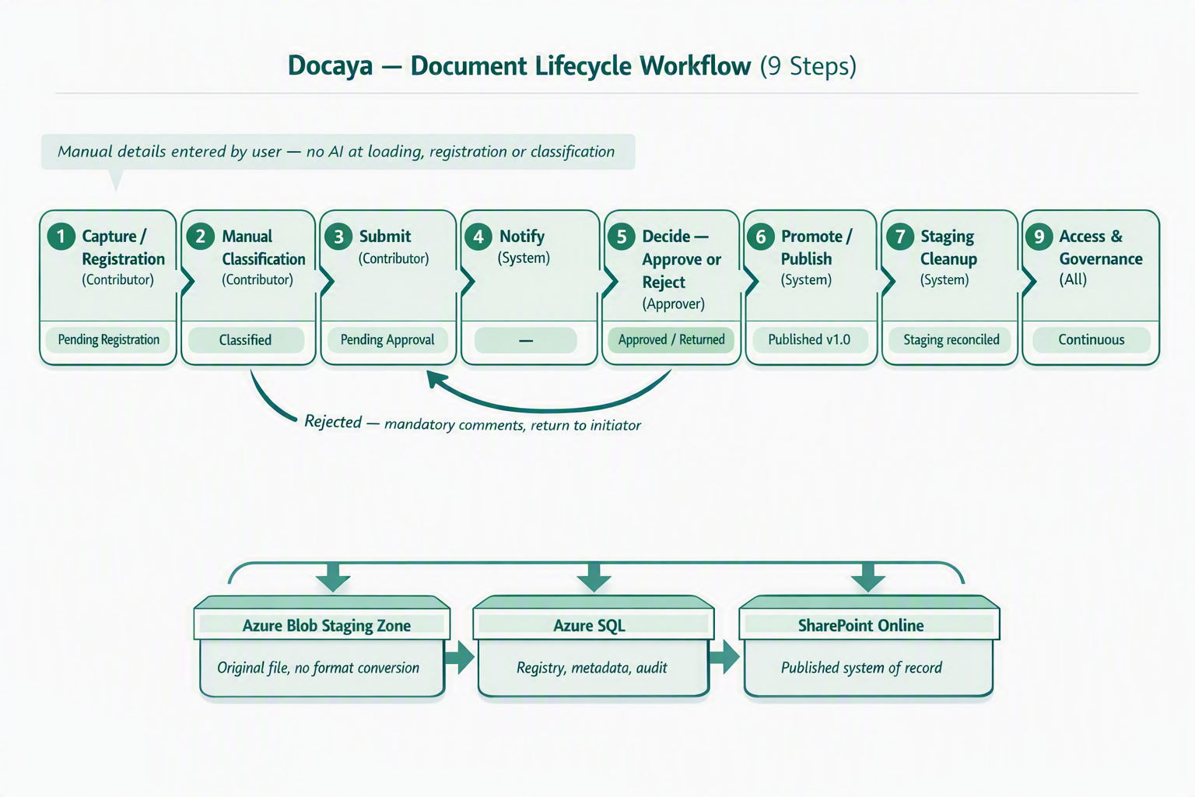

No |  | Stage | Actor | What happens | Status
1 |  | Capture / Registration | Editor / Change Requester | The Editor / Change Requester uploads a file (PDF, DOCX, XLSX, PNG, JPEG and other supported types). The original file is stored in the controlled Staging Zone (Azure Blob) - or, where configured, a staging area within a SharePoint site - without converting the file format. A unique tracking number (e.g., DOC-2026-000123) is issued, and a registry row is created in Azure SQL where the document is tracked, monitored and audited. Docaya captures technical attributes such as file name, detected type, size, hash and capture timestamp; the Editor manually completes the required registration fields before the approval flow starts. | Status → PendingRegistration / Draft
2 |  | Classify | Editor / Change Requester | The Editor manually classifies the document by selecting the document class, sensitivity, owning department and approval flow from Admin-configured values. No AI suggestion, OCR extraction, metadata recommendation or approval recommendation is provided during loading, registration or classification. All classification metadata is written to Azure SQL, and the configured approval flow starts once the required details are complete. | Status → Classified
3 |  | Submit | Editor / Change Requester | The Editor submits. Classification rules determine the target SharePoint library and the review chain. The document moves to PendingApproval and appears in the queue of the first configured review stage (Section 8.4). | Status → PendingApproval
4 |  | Notify | System | At every stage the Notification Center alerts the relevant parties in-app and via email / Microsoft Teams - including the approver on submission and the Editor on each stage decision. | (no status change)
5 |  | Decide | Reviewer at current stage | Each level in the configured three- or four-level review chain performs its own action. The reviewer approves to advance, or returns the item with mandatory threaded comments to the Editor or preceding level for correction and resubmission. SLA status, extensions, stage timings and every action are retained. Only final approval permits promotion to SharePoint. | Status → Approved or → Classified (returned)
6 |  | Promote / Publish | System | Only after final approval, Docaya promotes the approved original PDF, DOCX, PPTX, XLSX, image or other supported file from staging into the correct SharePoint library as the main repository and system of record. No file-format conversion occurs. The SharePoint item ID, URL and version are written back to Azure SQL. | Status → Published (v1.0)
7 |  | Cleanup | System | The staging copy is handled per policy - purged, or moved to a dedicated 'Published/Approved' folder within staging for retention. The Editor is notified of successful publication. | Staging reconciled
8 |  | Upload Processing | System (during upload) | While the supported original file is held in staging, Docaya extracts basic machine-readable text, technical metadata and preview data. Business and classification metadata remains user-entered. No content chunking, embeddings, vectors, generative retrieval or post-publish AI indexing is performed. | Staged file and extraction data ready for review
9 |  | Access & Governance | All | Users access Docaya via UAE PASS single sign-on federated to Entra ID. Access is managed inside Docaya, while the platform reaches SharePoint through a governed service identity that holds read/write on the document estate. This keeps user permissions centralised in Docaya while all content operations occur under one auditable service principal. | Continuous
 | Key promotion rule The original file remains in its native format in staging throughout capture, classification and approval. Only on approval is the same file promoted into the correct live SharePoint Online library and given version 1.0 - at which point it becomes an official Client record.

5.1 Status State Machine
State | Meaning | File location
Draft / PendingRegistration | Uploaded; auto-metadata populated; registration fields being completed | Staging (Blob / SP staging)
Classified | Class, sensitivity, department, approver flow selected | Staging
PendingApproval | Submitted; awaiting the decision of the current review stage | Staging
Returned | Returned with mandatory comments; back with Editor or the immediately preceding review stage | Staging
Approved | Approver signed off; promotion pending | Staging (transient)
Published | Promoted to SharePoint library; version 1.0 | SharePoint Online
Superseded | Replaced by a newer approved version | SharePoint Online
Expiring | Within the expiry notification window | SharePoint Online
Archived / Disposed | Retention reached; archived or defensibly deleted | Archive / removed per policy

6. Module M1 Capture & Document Registration
Upload and staging scope: During upload, Docaya extracts only basic machine-readable data, technical metadata and a text preview from supported files such as PDF, DOCX, PPTX, XLSX and common image formats. The original uploaded file and extracted data are retained in staging. No uploaded document is added to the main SharePoint repository/system of record until the configured approval workflow is completed; after approval, the document is promoted to the controlled repository.

6.1 Functional Design
- Multi-format capture: PDF, DOCX, XLSX, PPTX, PNG, JPEG/JPG, TIFF and other approved MIME types, validated by both extension and file signature.
- Multiple capture channels: d-and-drop (single & bulk), scan-to-PDF, and email-in to a per-department address (roadmap).
- Resumable, chunked upload for large files (up to 100 MB) with progress, cancel and retry.
- Staging-first store: the original file is written to the Azure Blob Staging Zone (or a SharePoint staging area where configured) in the same format - never directly to a live library and never converted to another format.
- Unique tracking number issued at capture in the format DOC-YYYY-NNNNNN, printed on screen and used across the whole lifecycle. This is called as Docaya Tracking Number
- Azure SQL registry row created immediately; the document is tracked, monitored and audited from this moment, with an initial status.
- Content integrity: a SHA-256 hash is computed for de-duplication and tamper detection; malware and DLP checks run before the item can proceed.

6.2 Auto-Populated vs. User-Entered Fields
On the registration screen Docaya auto-detects and pre-fills technical attributes; the Editor supplies the business context.
Auto-populated by Docaya (technical attributes) |  | Entered manually by the Editor
Document name (from file, editable) |  | Business title / subject
Detected document type / MIME |  | Document class (see M2)
File size and page count |  | Owning department
Content hash (SHA-256) |  | Sensitivity / handling marking
Capture timestamp & channel |  | Description / keywords / reference
Tracking number (DOC-YYYY-NNNNNN) |  | Retention / expiry hints (optional)
Uploader role / authenticated user reference |  | Approver flow selection
 | Registration = accountability The Azure SQL registry is the single source of truth for chain of custody. From the instant a tracking number is issued, every view, edit, decision and movement is recorded against it.

7. Module M2 Classification & Metadata
Classification is Editor-driven and rules-aware. The Editor selects all business and classification values manually from Admin-configured controls. Only technical attributes, basic machine-readable text and preview data are extracted during upload while the file remains in staging; no AI classification or is used.

7.1 Classification Dimensions
Dimension | Purpose | Example values
Document class | Determines target library & schema | Correspondence, Memo, Circular, Contract, HR Record, Report, Policy
Sensitivity / handling | Drives access & approval routing | Public, Internal, Confidential, Secret
Owning department | Ownership & routing | e.g., Finance, HR, Legal, Operations
Priority | Queue ordering & SLA | Routine, Priority, Urgent
Approval flow | Selects approver chain | Single, Sequential, Parallel
Access scope (ABAC) | Attribute-based restriction | Department-only, Named group, Clearance level
Standard | Groups the document for navigation, filtering and reporting by the standard it supports | ISO 9001, ISO 27001, Health & Safety, IMS, AI Governance

7.2 Manual Classification Controls
- User-entered business metadata: Docaya does not generate classification, business metadata or approval recommendations. During upload it extracts only basic machine-readable text, technical metadata and preview data for the staged file.
- Manual details required: the Editor manually enters or selects the business title, document class, sensitivity, owning department, description, keywords/reference and approval flow.
- Schema validation: metadata is validated against the configurable document-type schema before submission is allowed.
- Approval-flow enforcement: once the manual details are complete, Docaya routes the document through the configured approval flow.
- Azure SQL persistence: classification, workflow status, audit trail and SharePoint promotion references are fully auditable and reportable.

8. Module M3 Workflow & Approval

8.1 Submission & Routing
On submission, classification rules resolve the target SharePoint library and the approver(s). The document enters Pending Approval and is placed on the approver's queue with full context and preview.

8.2 Approval Patterns
Pattern | Behaviour | Typical use
Single | One approver decides | Routine internal documents
Sequential | Approvers act in order; each must approve to proceed | Confidential / multi-level sign-off
Parallel | Multiple approvers in parallel; quorum or unanimous | Cross-department documents
Conditional | Route by rule (e.g., sensitivity = Secret → senior + compliance) | Sensitive or high-value records

8.3 Decision Handling
- Approve: the document is marked Approved and immediately promoted (Module M4) to the final class/library selected by the Editor.
- Reject / Request changes: mandatory comments (more information) are required; the document returns to the initiator as Returned/Classified for correction and re-submission.
- SLA & escalation: each approval task carries an SLA timer; on breach it escalates to the configured delegate or manager and raises a notification.
- Act anywhere: approvers can decide from the in-app queue, email action buttons, or Microsoft Teams.
- Delegation: out-of-office auto-reassignment keeps the queue moving.
Mandatory rejection reason A rejection cannot be submitted without comments. This guarantees the initiator always receives actionable feedback and preserves a complete decision record in the audit trail.

8.4 Configurable multi-level review chain
The patterns in 8.2 remain routing primitives. The approval workflow is a configurable, named sequence of three or four levels set by the Admin Center per document type or department, with threaded comments and actions, return and resubmission, SLA and extension handling, stage timings, and complete audit/version history:
Stage | Default role | Purpose
1 | Editor / Change Requester | Submits a new document or a change request against an existing one
2 | Document Owner / Approver | First substantive review; approves or returns with comments
3 | Assurance | Quality/compliance check; approves, returns, or grants a timeline extension with a recorded reason
4 | Authoriser (typically CEO) | Final sign-off; approves for publication or returns for further amendment
- Admin-configurable: number of stages (3 or 4), role at each stage, and whether a stage is mandatory or optional are set per document type/department in M13 Admin Center - no engineering change required to adjust the route.
- Any stage can return the item to the Editor or to the immediately preceding stage with mandatory comments; the item re-enters the chain at the point of correction, not necessarily at Stage 1.
- Each stage inherits the SLA and escalation model described in 8.6.

8.5 Threaded comments & actions
Every submission, return, amendment and resubmission is captured in a per-document thread. Each entry records actor, role or stage, action, comment and timestamp. The thread is visible to subsequent reviewers and is retained with stage timings, SLA and extension events, full audit history and SharePoint version history for Module M16.

8.6 Change-request SLA & timeline engine
Each change request is classified as Urgent or Normal at submission, which sets its target completion window in working days (public holidays and weekends excluded):
Request type | Target | Extension
Urgent | 12 working days end-to-end | Assurance can approve an extension; reason is mandatory and recorded on the thread
Normal | 30 working days end-to-end | Assurance can approve an extension; reason is mandatory and recorded on the thread
- A running remaining-days counter is shown on every request; requests within a configurable warning window are flagged ‘at risk’, and requests past target are flagged ‘overdue’ - both are terms the Notification Center (M7) can alert on.
- Stage-level duration is captured automatically: the time an item spends with each of Document Owner, Assurance, and Authoriser is stored against the thread entry for that stage, so a delay can be attributed to a specific stage rather than only shown as ‘overdue’ in aggregate. This feeds the bottleneck reporting in Module M15.
- Extensions are logged as a distinct event type (new target date, approver, reason) so the original target is never overwritten - both dates remain visible for reporting.
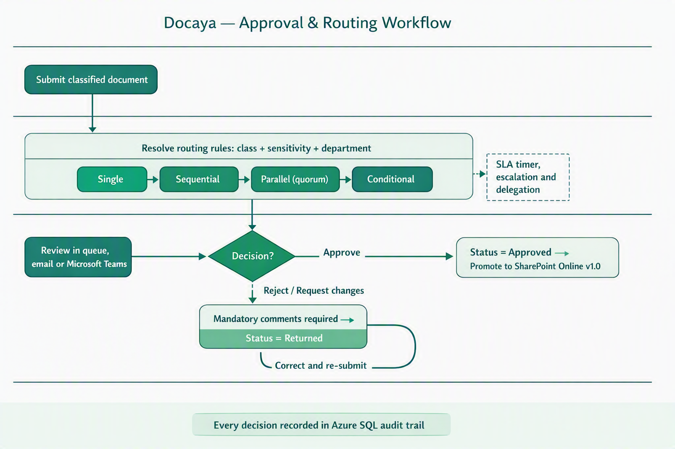

Figure 2 - Approval and routing workflow: rule-based routing, the four approval patterns, SLA escalation and the mandatory-comment return path.

9. Module M4 Promotion & Publishing
- Immediate promotion: on approval, Durable Functions orchestrate the move from staging into the correct live SharePoint library path for the document's final class.
- Microsoft Graph upload transfers the original file stream without changing the file format; SharePoint's native versioning assigns version 1.0.
- Write-back to Azure SQL: SharePoint Item ID, Drive/Library ID, web URL and version label are captured on the registry row, linking record and content.
- Idempotent promotion: an idempotency key ensures a retry can never create a duplicate SharePoint item.
- Native versioning thereafter: subsequent approved edits create new SharePoint versions (2.0, 3.0 …); Docaya records the version label.
- Failure safety: if promotion fails, the item remains recoverable and visible in staging; the original file is never lost.

10. Module M5 Staging Lifecycle & Cleanup
Situation | Cleanup behaviour
Document published | Staging copy of the original file purged, OR moved to a dedicated 'Published / Approved' folder in staging per retention policy
Document rejected / returned | Original file retained in staging under the initiator until corrected and re-submitted
Abandoned draft | Auto-expiry after a configurable period, with owner notification before removal
Failed promotion | Original file retained and flagged for operational replay via idempotent retry
- Lifecycle rules on the staging container keep stoe costs controlled while preserving auditability.
- Editor / Change Requester notified of successful publication with a direct link to the SharePoint record.

11. Module M6 Upload Text Extraction & Search Data
A scheduled batch process builds and maintains a document metadata and text-preview processing index using Azure metadata and full-text search. It draws on both the document metadata registered in Azure SQL (all information the initiator and approver entered on screen) and the published content in SharePoint, enabling the metadata and full-text search and inside the application.

11.1 Pipeline Stages
Stage | Action | Output
1 · Stage | Store the original supported file in controlled staging | Original file retained unchanged
2 · Extract | During upload, extract basic machine-readable/source text, technical metadata and preview data | Staged technical extraction data
3 · Register | User enters business title, class, sensitivity, department, keywords and approval route | Validated business metadata
4 · Review | Run the configurable three- or four-level review with threaded actions, return/resubmission, SLA, extensions and stage timings | Complete review and audit history
5 · Promote | After final approval, promote the approved file to SharePoint as system of record | Approved SharePoint version
6 · Search | Search approved records using permission-trimmed metadata and full-text/source-text matching | Authorised search results

11.2 Design Principles
- Grounded & cited: 'document search' searches only indexed Client documents the user is permitted to see, with links back to the exact document/version.
- Permission-trimmed retrieval: every query carries the user's effective ACL keys; the index never returns content the user cannot access.
- Metadata + content fusion: because all registration data lives in Azure SQL, search can combine structured filters (department, class, sensitivity, date) with.
- Batch cadence: configurable schedule (e.g., near-real-time micro-batches or scheduled runs) with full re-index capability.
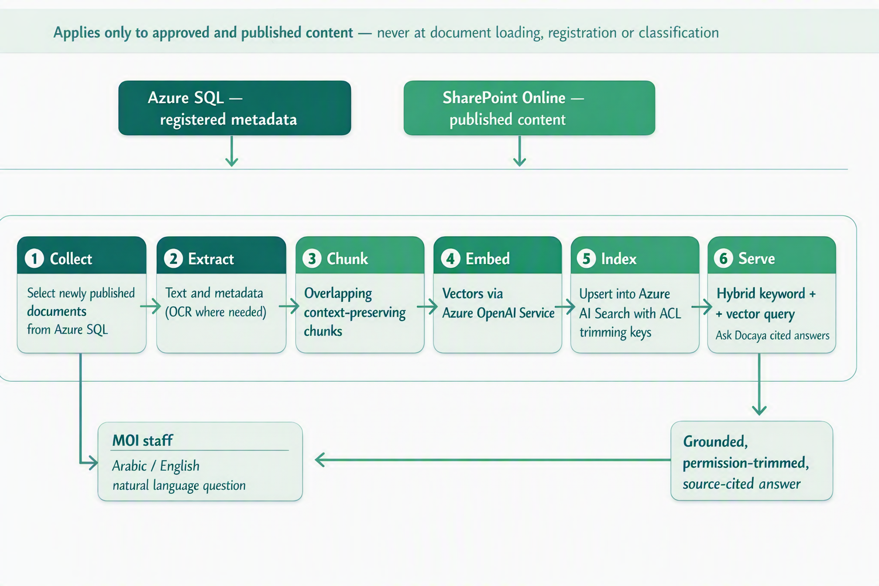
Figure 3 - Batch document indexing indexing and search pipeline, applied only to approved and published content.
Why document indexing for the Client document indexing turns the approved document estate into an answerable knowledge base: staff ask natural-language questions in Arabic or English and receive concise, source-search results drawn only from published documents they are authorised to view. It is never applied at document loading, registration or classification.

12. Module M7 Notification Center
The Notification Center is a first-class surface that keeps every actor informed at every lifecycle stage, with zero noise.
Category | Examples | Default channels
Workflow | Approval requested, approved, rejected, SLA breach, escalation | In-app, Email, Teams
Registration | Document registered, submitted, returned for changes | In-app, Email
Publication | Successfully promoted to SharePoint, new version | In-app, Email
Expiry / Lifecycle | T-30 / T-7 / T-1 day reminders, retention due | In-app, Email
Security | Permission change, unusual access, external share (locked, mandatory) | In-app, Email, Push
System | Stoe, maintenance, upload-processing status | In-app, Email
Change request | SLA at-risk warning, overdue flag, extension granted | In-app, Email, Teams
- Real-time delivery via Azure SignalR; durable history retained in Azure SQL.
- Per-user preferences per notification type and channel; security notifications are mandatory and non-disable-able.
- Smart batching, DND windows and de-duplication prevent alert fatigue; delivery via email (ACS) and Teams/Outlook (Graph).

13. Module M8 Correspondence Management
Client organisations run on correspondence. Docaya adds a dedicated correspondence capability on top of the core pipeline, designed to support the Client’s day-to-day operational requirement.
- Incoming & outgoing correspondence captured with a formal reference number, sender/recipient, subject and due date.
- Memos & circulars with structured templates, distribution lists and read-acknowledgement tracking.
- Linking & threading relate a reply to its original correspondence to preserve the full thread.
- Routing & action tracking assign, forward, and track actions with due dates and escalation.
- Bilingual Arabic/English correspondence with RTL layout.

14. Module M9 Records, Retention & Legal Hold
Capability | Design
Retention schedules | Time-based or event-based policies per document class, aligned to the Client's records policy
Disposition | Auto-archive, review-then-delete, or defensible permanent deletion with approval
Legal hold | Overrides retention; freezes documents, blocks deletion, fully audited
Records declaration | Freeze metadata + content for compliance / evidential integrity
Archive tiering | Move cold records to archive stoe while preserving the registry link
Data residency | All data pinned to UAE Azure regions to satisfy PDPL and IA requirements

15. Module M10 Search & Discovery – Ask Docaya
- Search combines permission-trimmed metadata, full-text/source-text matching and faceted filters.
- Faceted filters: class, department, sensitivity, owner, date, status, tracking number.
- Permission-trimmed: results always honour the user's effective rights (no unauthorised results).
- Permission-trimmed metadata and full-text/source-text search across approved documents (Module M6).
- Saved searches & smart views for recurring departmental queries.

15.1 Department / standard navigation
The document library view is organised as tabs or categories by Department and/or Standard (e.g. Health & Safety, AI, IMS, Information Security, Finance, HR). The grouping taxonomy is Admin-configurable in M13 so new departments or standards can be added without a release.

15.2 One-click access
From any listing row the user can view the document (in-browser preview), download the original file, or open its SharePoint folder - each in a single click, subject to the user’s effective permission (Module M12).

15.3 Extended filters
The faceted filters above are extended with: document name (free text), standard, owner, and status, so results can be narrowed the same way whether the user is browsing by department tab or running a search.

16. Module M11 Identity, SSO & SharePoint Integration

16.1 Single Sign-On with UAE PASS
- UAE PASS as primary identity: users sign in with the UAE national digital identity, federated to Microsoft Entra ID for the Docaya application.
- Standards-based: OIDC + PKCE for the single-page app; MFA and Conditional Access enforced by Entra.
- Step-up authentication for sensitive actions such as approving Secret documents or changing permissions.

16.2 Governed SharePoint Service Identity
Docaya integrates with SharePoint through a single governed service identity (system/service principal) that holds read and write access across the Docaya document estate. Once a user signs in to Docaya, their access is managed within Docaya (RBAC + ABAC), while all content operations against SharePoint are performed under this one auditable service identity.
Aspect |  | Design decision | Benefit
User access |  | Centrally managed inside Docaya (roles + attributes) | Single, consistent control point
SharePoint access |  | Performed by the Docaya service identity (read/write on the estate) | Uniform, auditable content operations
Credential |  | Managed identity / workload identity - no stored user passwords | Least-privilege, no secret sprawl
Authorization |  | Docaya enforces who can see/do what before any SharePoint call | Defence in depth
Audit |  | Every action attributed to the real user in Azure SQL, executed by the service identity | Full accountability
 | Integration model Users never touch SharePoint permissions directly. Docaya is the governance layer: it decides access, then acts on SharePoint Online through one controlled Entra ID service identity - keeping permission management simple, centralised and fully audited.

17. Module M12 Access Control (RBAC + ABAC)
- RBAC: roles/app-roles (Section 3) grant baseline capabilities.
- ABAC overlays: attributes such as department, sensitivity and clearance refine access (e.g., 'Confidential HR records visible to HR only').
- Deny-by-default: no access unless explicitly granted; every decision is logged.
- Effective-permission evaluation combines role + attribute + document scope before any read, download or action.

18. Module M13 Admin Center
A no-code control plane so Client administrators configure the system without engineering tickets.
Area | Configurable items
Document types & schemas | Create/edit classes, metadata fields, validation, controlled vocabularies
Routing rules | Map class + sensitivity + department to target library and approvers
Workflows | Design single/sequential/parallel/conditional flows; SLA & escalation
Notifications | Templates (Arabic/English), default channels, quiet hours
Retention & legal hold | Schedules, dispositions, holds
Security | MFA enforcement, session policy, step-up rules, IP allowlists
Branding & localisation | Client branding, bilingual labels, RTL defaults
Integrations | Service identity, connectors, webhooks, API keys
Approval-level designer | Number of review stages (3–4), role per stage, mandatory/optional flag, SLA targets (urgent/normal working days), at-risk warning window, who may grant extensions - scoped globally, by document type, or by department
Navigation taxonomy | Department and Standard categories shown as tabs in the document library (Section 15.1)

19. Module M14 - Existing Document Modification
Existing Document Modification is a dedicated change-control module for amendments to documents that have already been approved and published in SharePoint Online. It prevents uncontrolled overwrites by requiring every change to begin as a formal change request against the current approved version. The requester selects the published document, reviews the current metadata and version, records the business rationale, selects the change priority, uploads or prepares the proposed amended file, and submits the request into the governed approval workflow.
The proposed revision follows the same configurable three- or four-level review workflow used by Module M3, including threaded comments, mandatory return reasons, resubmission, working-day SLA controls, extension approvals, stage timings and complete audit history. Final approval does not replace the record silently: Docaya promotes the approved amended file as the next SharePoint version, links the change request to the new version label, and preserves the prior approved version for audit, rollback comparison and historical reference.

19.1 Functional Scope
- Change request initiation: the requester opens the approved document record and selects Request Modification. Docaya validates that the user has permission to request a change and that the document is not already locked by another active request.
- Current-version protection: the approved SharePoint version remains read-only while the proposed amendment is prepared and reviewed. No live document is overwritten before final approval.
- Business justification: rationale, change type, affected section, priority, target date and supporting attachments are captured as mandatory request metadata.
- Amendment preparation: the requester uploads the revised file or attaches amendment notes. Docaya links the proposed file to the original tracking number and creates a change-request number for end-to-end traceability.
- Comparison support: reviewers can compare the current approved version with the proposed amendment, view requester comments, and inspect prior decision history before approving or returning.
- Version preservation: when approved, the proposed amendment is promoted as the next SharePoint version. The previous version remains available through SharePoint version history and Docaya audit history.
- Concurrency and locking: only one active change request can exist against a document at any time. Docaya locks the record on initiation and blocks or queues any further modification request until the active one is approved, rejected or withdrawn, preventing conflicting parallel amendments.
- Impact classification: each request is classified as a minor or major amendment. The classification drives the required number of review stages, the applicable SLA target (urgent or normal) and the set of mandatory reviewers for that change.
- Withdrawal and cancellation: the requester may withdraw a change request at any point before final approval. Current-version protection is released, the change-request number is closed with a mandatory cancellation reason, and no new version is created.
- Stakeholder notification: every transition — submission, stage approval, return, SLA at-risk, overdue, extension decision and publication — raises in-app, email and Teams notifications to the responsible role via the Notification Center (M7).
- End-to-end traceability: the change-request number, the original document tracking number, all SLA and extension events, reviewer decisions and SharePoint version labels are linked so the complete history of any amendment can be reconstructed for audit.

19.2 SLA and Extension Request Handling
Each M14 change request is governed by an end-to-end working-day SLA. Urgent requests target completion within 12 working days and Normal requests target completion within 30 working days, excluding weekends and configured public holidays. The SLA starts when the request is submitted and remains visible on the request header, reviewer queue, notification messages and analytics dashboards.
The end-to-end SLA parameters that govern every M14 change request are summarised below. Working days exclude weekends and any public holidays configured in the Admin Center (M13).
SLA parameter | Urgent request | Normal request
End-to-end target | 12 working days | 30 working days
SLA start | On submission of the change request | On submission of the change request
Calendar basis | Working days (weekends & configured public holidays excluded) | Working days (weekends & configured public holidays excluded)
At-risk warning | Configurable window raised before the target date to the responsible stage | Configurable window raised before the target date to the responsible stage
Overdue action | Marked Overdue, escalated per configured route, included in breach reporting | Marked Overdue, escalated per configured route, included in breach reporting
Extension approver | Assurance — justification mandatory | Assurance — justification mandatory
Baseline on extension | Original target retained for reporting; revised date stored as a separate extension event | Original target retained for reporting; revised date stored as a separate extension event
Throughout the SLA lifecycle Docaya manages the following events:
- At-risk warning: Docaya flags the request before the SLA breach using a configurable warning window and notifies the current responsible stage.
- Overdue handling: if the target date is missed, the request is marked Overdue, escalated according to the configured route, and included in SLA breach reporting.
- Extension request: the requester or current reviewer can request more time by entering the requested new date, justification, impact and supporting comment.
- Extension approval: Assurance reviews the extension request and either approves a revised target date or rejects it with a mandatory comment. The original SLA date is retained for reporting; the revised SLA date is stored as a separate extension event.
- Audit visibility: all SLA events, at-risk alerts, overdue flags, extension requests, approvals and rejection reasons are retained in the document-level thread and surfaced in Module M15 analytics.
An approved extension revises only the working target date; the original SLA baseline is always preserved for breach reporting, and the complete extension trail is shown in the SLA Extension Request process flow (19.4).

19.3 Process Flow
The diagram below shows the end-to-end change-request flow. The numbered step detail follows in the table beneath it.
Requester opens the approved document and selects “Request Modification”
▼
System validates the requester’s permission and confirms the record is not already locked by another active change request
▼
Permitted and available? — No → request blocked, requester notified
▼
Requester captures business justification (rationale, change type, affected section, priority, target date, attachments) and uploads the proposed amended file
▼
System locks the current approved version (read-only), generates the change-request number, and starts the SLA timer — Urgent 12 / Normal 30 working days
▼
Configurable 3–4 stage review chain: Owner/Approver → Assurance → Authoriser — reviewers compare versions, add threaded comments, and approve or return
▼
Approved at each stage? — Returned → back to requester for rework and resubmission
▼
SLA engine monitors throughout — at-risk warning, overdue flag, escalation and extension requests (see 19.4)
▼
Authoriser grants final approval for publication
▼
System promotes the amendment as the next SharePoint version, preserves the prior version, updates the registry, and notifies stakeholders

Step | Actor | Action / Decision | Status / Output
1 | Requester | Selects approved document and chooses Request Modification. | Change request draft created
2 | System | Locks the live approved version from overwrite and creates a linked change-request number. | Current version protected
3 | Requester | Adds rationale, priority, target date and proposed amendment. | Ready for submission
4 | System | Starts urgent or normal SLA timer and routes to the configured review chain. | Pending approval
5 | Reviewer / Approver | Reviews comparison, comments and supporting information; approves or returns with mandatory comments. | Advanced / Returned
6 | Assurance | Reviews SLA extension requests and approves or rejects with reason. | SLA retained or revised
7 | Authoriser | Provides final approval for publication or returns for amendment. | Approved / Returned
8 | System | Promotes approved amendment to SharePoint as the next version and updates the registry. | Published new version

19.4 SLA Extension Request — Process Flow
An extension never resets the SLA clock automatically. Any additional time must be requested, justified and approved by Assurance before the working target date changes. The diagram shows the extension sub-process; the step detail follows in the table.
SLA at-risk warning raised, or requester/reviewer needs more time to complete the change
▼
Requester or current reviewer raises an Extension Request — proposed new target date, justification, impact assessment and supporting comment
▼
System records the extension event, keeps the original SLA date, and routes the request to Assurance
▼
Assurance approves the extension?
▼
✗ Rejected — mandatory comment recorded; original SLA date stands; request continues and may breach / escalate
✓ Approved — revised target date applied; original target retained for reporting; stored as a separate extension event
▼
SLA header, reviewer queue and notifications updated; all events logged to audit history and surfaced in M15 analytics
Extension request — step detail:
Step | Actor | Action / Decision | Status / Output
1 | Requester / Reviewer | Raises an extension request with proposed new date, justification and impact. | Extension requested
2 | System | Logs the extension event, retains the original SLA date, and routes to Assurance. | Pending Assurance
3 | Assurance | Reviews justification and impact; approves or rejects with a mandatory comment. | Approved / Rejected
4 | System (if approved) | Applies the revised target date and stores it as a separate extension event. | SLA revised
5 | System (if rejected) | Keeps the original SLA; the request continues and may breach or escalate. | SLA unchanged
6 | System | Updates the SLA header and notifications; logs to audit history and M15 analytics. | Extension trail recorded

20. Module M15 - Analytics
Docaya delivers native, in-application analytics: reports and dashboards are built on Power BI and rendered directly inside Docaya, so users see governed, permission-trimmed reporting without a separate BI tool, licence or login. Every report reads from the same Azure SQL registry, classification, workflow and audit stores populated by Modules M1-M16 - there is no separate analytics pipeline or data duplication to maintain.

20.1 Reporting & Power BI Architecture
- Embedded Power BI: reports and dashboards are embedded in the Docaya UI via Power BI Embedded, so no separate Power BI licence or sign-in is required for end users.
- Reporting data model: a dedicated semantic model / reporting layer sits over Azure SQL, covering the document registry, classification metadata, workflow and stage-timing data, and the audit store.
- Refresh cadence: operational dashboards (pending approvals, SLA status) reflect near-real-time data; trend and historical dashboards refresh on a scheduled cycle.
- Row-level security: Power BI row-level security mirrors Docaya's RBAC + ABAC model, so each user's dashboards and exports are automatically trimmed to the documents, departments and classes they are permitted to see.

20.2 Metadata & Classification Reports
Reports driven by document metadata captured at registration and classification (Modules M1-M2):
- Volume analysis: document counts by class, department, standard and status, with period-over-period trend.
- Sensitivity distribution: breakdown of documents by sensitivity marking, for governance and risk reporting.
- Most-accessed & most-downloaded: top records by view/download activity, permission-trimmed to the viewer.
- Stale or inactive content: documents not reviewed, updated or accessed within a configurable period.
- Ownership view: documents grouped by owner, business unit or department for accountability reporting.

20.3 Workflow & Change-Request Reports
Operational dashboards: documents registered, pending approvals, cycle time, SLA compliance and promotion backlog, all drawn from the workflow engine (Module M3).

Docaya's native reporting module already connects to Azure SQL for the dashboards above (Section 22.1). Four additional dashboards read from the stage-level timing and thread data captured by Module M3 and the audit store in Module M16 - no separate analytics pipeline is required:
Dashboard | Content
Change requests | Total open / closed / overdue, urgent vs normal split, average completion time, monthly trend
Department / user analysis | Requests raised by department and by user, filterable by month/year
Performance | % completed within target, overdue count, extensions granted, average time spent at each approval stage
Document control | Documents due for review, overdue reviews, pending approvals, recently revised documents, documents by department/standard

20.4 Audit & Compliance Reports
- Compliance dashboards: documents under retention, upcoming dispositions, active legal holds and access anomalies.
- Full audit exports: the tamper-evident audit trail (Module M16) - who did what, to which document, and when - exportable per document, per user or per date range for regulator or internal audit requests.
- e-Signature status: completion certificates and outstanding signature requests for approvals requiring signed sign-off.
- Access anomaly flags: unusual download or access patterns surfaced for review.

20.5 Standard Reports Library & Export
- Standard report templates: a pre-built library covering each area above (metadata, workflow, audit, compliance), runnable on demand or on a schedule.
- Scheduled reports & exports: PDF/XLSX/CSV, delivered in-app or by scheduled email subscription.
- Access-report builder: an ad hoc, filterable builder for audits - by date range, department, class, document type or user.

21. Module M16 - Audit & Compliance
- Tamper-evident audit: every action (register, classify, submit, decide, promote, view, download, permission change) recorded in a hash-chained Azure SQL audit log.
- Full attribution: actor, action, object, tracking number, timestamp, request ID, source IP and outcome.
- e-Signature: native or integrated e-signature for approvals requiring signed sign-off, with certificate of completion.
- Standards alignment: designed for UAE IA standards, PDPL, ISO 27001 and records-management best practice, as required by the Client.

21.1 Full audit trail & version history
The audit log above now surfaces as a document-level history view combining: who requested the change, every comment raised at every stage, amendments made, decision dates, approvals/rejections, links to previous file versions (via M4’s SharePoint versioning), and the current approved version. This is the thread described in Module M3, Section 8.5, rendered as a single chronological record per document.
- Every thread entry remains individually attributed and timestamped, consistent with the existing audit model.
- Version history links the audit thread to the specific SharePoint version (v1.0, v2.0, …) that resulted from each approval, so any past state of a document can be reconstructed.

22. Reference Architecture
The architecture has been revalidated against the updated functional flow: manual registration and classification with no AI at document loading, no file-format conversion between staging and publication, and approval-driven promotion into SharePoint Online. Every component below is a native Azure or Microsoft 365 service - no third-party platform is required. The staging-first promotion path is the backbone of the governed lifecycle.

22.1 Solution Architecture - Azure & Microsoft Building Blocks
Layer | Microsoft / Azure service | Role in the updated flow
Experience | Azure Static Web Apps / Azure App Service, Microsoft Teams & Outlook surfaces | Bilingual (AR/EN, RTL) web client for upload, manual registration form, approver queue and search
Identity | UAE PASS federated to Microsoft Entra ID; Entra managed identity | SSO, MFA and Conditional Access for users; secretless service identity for SharePoint operations
API & gateway | Azure API Management, Azure Front Door / Application Gateway (WAF) | Secure entry point, throttling, token validation and routing to Docaya services
Application | Azure App Service / Azure Container Apps | Registration, classification, workflow, admin, notification and search services (M1–M16)
Orchestration | Azure Durable Functions, Azure Service Bus | Approval routing, SLA timers, escalation and idempotent promotion of the original file
Staging store | Azure Blob Stoe (private endpoint) or a configured SharePoint staging area | Holds the file in its original format until approval; no conversion, lifecycle rules for cleanup
Registry & audit | Azure SQL Database | Tracking number, manually entered metadata, status, approval decisions and hash-chained audit
System of record | SharePoint Online via Microsoft Graph | Final library for the approved original file, native versioning from v1.0
Search (post-publish) | Azure metadata and full-text search + Service (batch document indexing) | Indexes approved content only - never invoked during loading, registration or classification
Notifications | Azure SignalR Service, Azure Communication Services, Microsoft Graph (Teams/Outlook) | Real-time in-app alerts plus email and Teams delivery at every lifecycle stage
Security & ops | Azure Key Vault, Microsoft Defender for Cloud, Microsoft Purview, Azure Monitor & Log Analytics | Key management, threat protection, classification/DLP, observability and IA/PDPL evidence
Analytics | Docaya native reporting module backed by Azure SQL | Operational, compliance and lifecycle dashboards (M15) + change-request governance dashboards (Section 20.3)

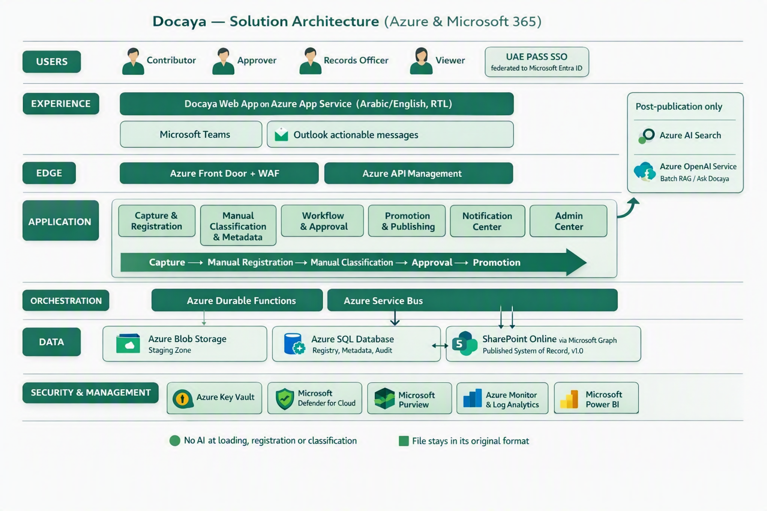
Figure 4 - Docaya solution architecture on Azure and Microsoft 365: staging-first capture, manual registration and classification, approval-driven promotion in the original file format, and AI/document indexing applied only after publication.

22.2 Application Architecture - Component View
Component | Responsibility | Depends on
Capture & Registration Service (M1) | Chunked upload, format and signature validation, SHA-256 hash, tracking number, registry row | Azure Blob Stoe, Azure SQL, Defender for Stoe
Classification Service (M2) | Serves Admin-configured dropdowns, validates the manually entered metadata against the type schema - no AI inference | Azure SQL, Admin Center configuration
Workflow Engine (M3) | Resolves the configured approval flow, manages SLA timers, escalation and delegation; now also resolves the multi-stage review chain and working-day SLA targets (Section 8.4–8.6) | Azure Durable Functions, Service Bus, Azure SQL
Promotion Service (M4) | Idempotent transfer of the original file stream to the target library and write-back of item ID, URL and version | Microsoft Graph, SharePoint Online, Entra managed identity
Staging Lifecycle Service (M5) | Purge, retain or move the staging copy after publication; replay failed promotions | Azure Blob lifecycle rules, Azure Functions
document indexing Indexing Service (M6) | Scheduled batch enrichment, chunking, and indexing of published documents only | Azure metadata and full-text search, Service, SharePoint Online, Azure SQL
Notification Service (M7) | Event fan-out, batching, quiet hours and multi-channel delivery | Azure SignalR, Azure Communication Services, Microsoft Graph
Access Control Service (M12) | Evaluates RBAC + ABAC effective permission before any read, download or content operation | Microsoft Entra ID, Azure SQL policy store
Admin, Reporting & Audit (M13–M15) | No-code configuration, dashboards and tamper-evident audit trail; now includes the approval-level designer and the per-document comment/version thread | Azure SQL, Docaya native reporting module, Azure Monitor, Microsoft Purview

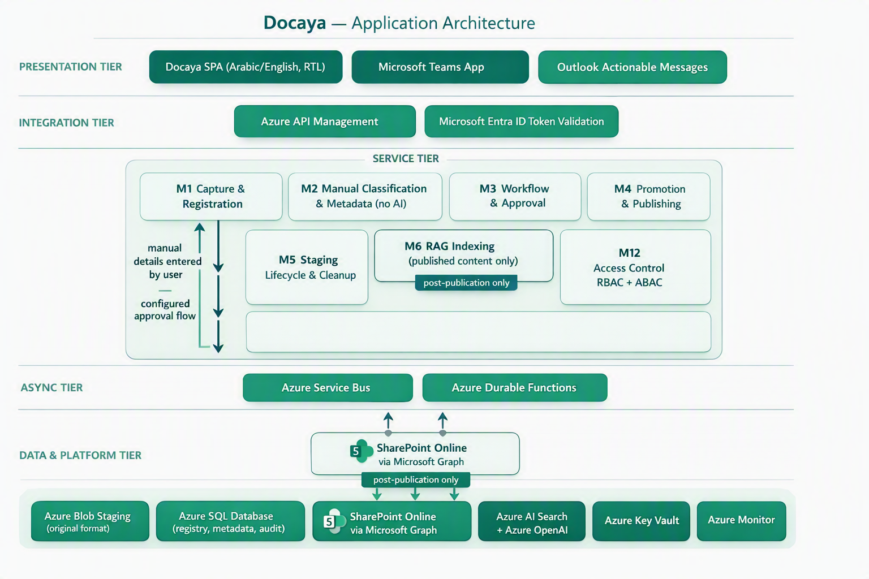
Figure 5 - Docaya application architecture: presentation, integration, service, asynchronous and data tiers across Azure and Microsoft 365.

23. Non-Functional & Compliance Targets
Attribute | Target
Availability | 99.9% baseline (higher tier by service design)
Page load | p95 < 1.5 seconds
Search latency | p95 < 400 ms (permission-trimmed)
Max file size | Up to 5 GB (resumable, chunked)
Recovery | RPO ≤ 5 minutes · RTO ≤ 1 hour
Accessibility | WCAG 2.2 AA; Arabic & English (RTL)
Data residency | UAE Azure regions only
Security | UAE IA standards, PDPL, ISO 27001 alignment; zero-trust, least privilege
Change-request SLA | Urgent: 12 working days end-to-end · Normal: 30 working days; extensions granted by Assurance only, with a recorded reason (Section 8.6)
Review-stage transparency | Stage-level duration captured automatically; at-risk and overdue alerts raised before the target date (Sections 8.6, 20.3)

24. Delivery Roadmap
Phase | Scope | Indicative timeline
MVP | UAE PASS SSO, capture→staging, classification, approval, promotion, versioning | Months 1–5
V1 | Notification Center, Admin Center, correspondence, search, reporting | Months 5–8
V2 | permission-trimmed metadata and full-text/source-text search, retention/legal hold, analytics, integrations | Months 9–12
- V1 scope (NEW addition) - configurable multi-level review chain, threaded comments, change-request SLA engine, and department/standard navigation are targeted for V1 alongside the Admin Center, since they extend the same modules (M3, M10, M13).
- V2 scope (NEW addition) - the four change-request Docaya native in-application reports and analytics (Section 20.3) are targeted for V2 alongside the existing analytics scope.

25. Assumptions, Decisions & Next Steps

25.1 Key Design Decisions
ID | Decision | Status
D1 | SharePoint Online remains the published system of record | Accepted
D2 | All content follows staging → classify → approve → promote | Accepted
D3 | UAE PASS federated to Entra ID is the primary SSO | Accepted
D4 | SharePoint accessed via one governed service identity; user access managed in Docaya | Accepted
D5 | metadata and full-text search delivered via a batch configured document processing workflow on Azure metadata and full-text search | Accepted
D6 | Azure SQL is the authoritative registry, audit and metadata store | Accepted
D7 | The approve/reject gate becomes a configurable 3–4-stage review chain (Editor → Owner/Approver → Assurance → Authoriser) | Proposed
D8 | Change-request SLA targets default to 12 working days (Urgent) and 30 working days (Normal), extendable only by Assurance with a recorded reason | Proposed

25.2 Immediate Next Steps
- Confirm the Client's document classes, sensitivity markings and departmental library map.
- Finalise UAE PASS ↔ Entra ID federation and the SharePoint service-identity permission scope.
- Approve the retention schedule and legal-hold policy with Records & Compliance.
- Configure the approval routing rules per class and sensitivity in the Admin Center.
- Stand up the upload-time extraction and search-data processing and validate permission-trimmed retrieval.
- Run an end-to-end pilot (capture → publish → search) with one department before rollout.
- Confirm the default 4-stage review chain and any department-specific variants.
- Confirm the working-day calendar (weekends and public holidays) used for the 12/30-day SLA targets.
- Confirm the department/standard taxonomy for navigation tabs.
- Review the four Docaya native in-application report layouts against the Client's procedure document once received.
Review outcome required Endorse the revised 9-step lifecycle, the manual classification model, the no-format-conversion promotion rule, the UAE PASS + service-identity integration, and the revalidated Azure/Microsoft reference architecture, together with the v2.1 review-chain, SLA and native analytics additions so build can proceed against this baseline.
- End of Document -

